

**Mawlana Bhashani Science & Technology University**

**Lab Report No : 01**

**Course Code : ICT-3106**

**Course Title : Microprocessor and Assembly Language Lab**

**Submitted by Submitted to**

**Name : Maskur Al Shal Sabil S.M. Shamim**

**Id: IT18021 Lecturer**

**3rd year 1st semester Dept of ICT,**

**Session : 2017-2018 MBSTU**

**Dept of ICT**

**MBSTU**

# Name :Maskur Al Shal Sabil

**Id : IT18021**

**1. Write an assembly program to print a character.**

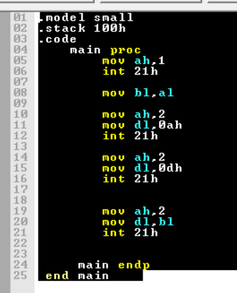

**Register :**

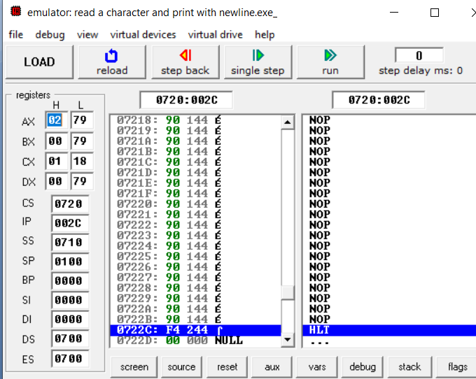

**Output** :

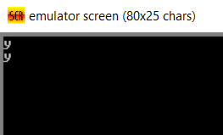

Explanation:

Line 1 is the model name of the assembly language it can be large or small

Line 2 where we define the stack size

.code is the code segment starting of the code

Mani proc is the starting of our main procedure

Mov ah,1 is instruction to read input . to execute this instruction we need to call the interrupt using interrupt function int 21h

Line 8 – we transfer the data of of al register to the bl register

Line 9 – execute the instruction ah,2 to display a character

Line10- where we put 0ah in dl register so when the interrupt will call in Line 12 a new line will print

Line 15- where we put dl, 0dh which is a carriage return

Line 20- we print the stored value of bl through dl register

And then end proc which is the ending block of main proc. And Finally end .

**Problem 2: write a program to print a number**

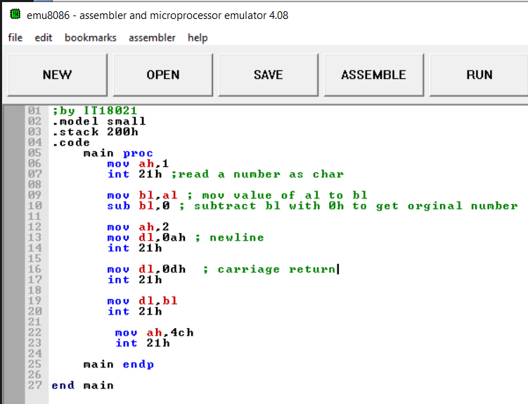

**Output:**

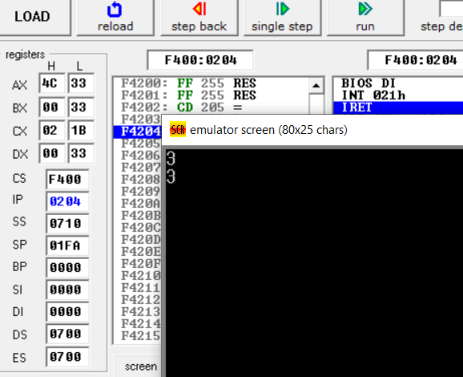

**3. Write an assembly program to print several characters with new line.**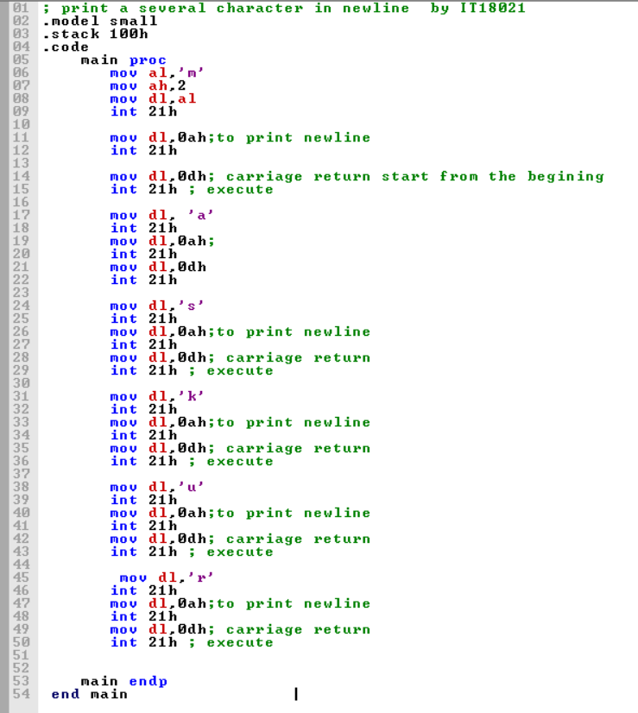

Output:

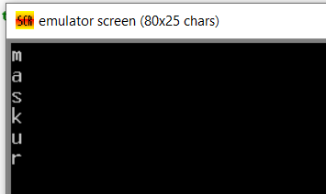

Explanation:   
Mov al , “ch” using this instruction we put ch character into the al register and then using interrupt we print the character . for newline we put 0ah in dl register and call int 21h. For starting the next line from the beginning we use the 0dh in dl register to accomplish carriage return .

**4. Write an assembly program to print several digits with new line.**

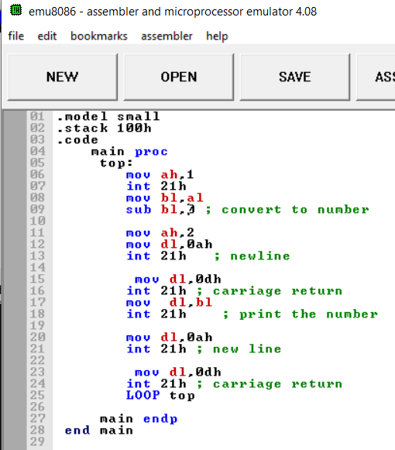

**Output :**

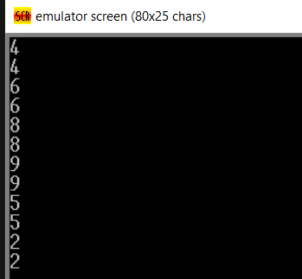

**5. Write an assembly program to enter character or digit and display it on the screen with new line.**

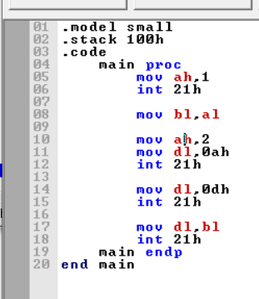

**Output:**

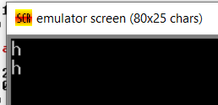

**6. Write an assembly program to enter several character or digit and display it on the screen with new line.**

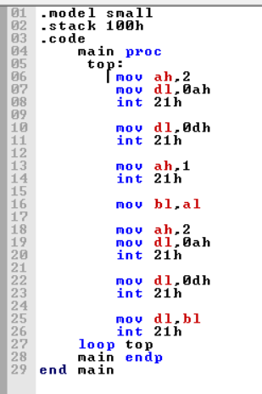

**Output:**

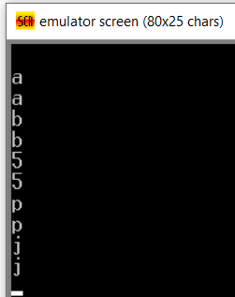

**7. Write an assembly program to print a character or digit using variable.**

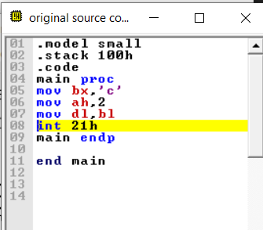

**Output:**

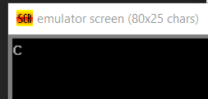

**8. Write an assembly program to print a string.**

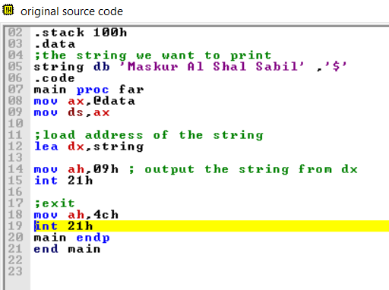

**Output:**

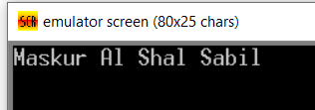

**Explanation :**

In the data segment we put the string which want to print.

MAIN PROC FAR ;The directives PROC and ENDP are used to define a label for a ;sequence of machine instructions called a procedure. ;FAR: Defines a far procedure. A Far call refers a procedure which is in different code segment;It is also **called Intra-segment call.**

**9. Write an assembly program to print a string and enter character/digit and display it.**

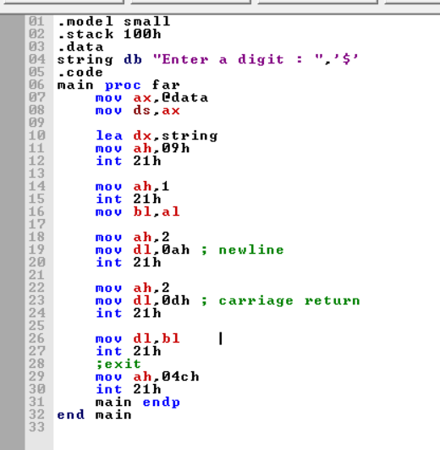

**Output :**

**Before enter input**

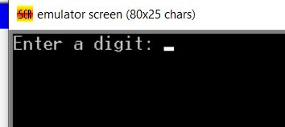

**After pressing input**

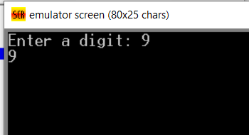

**10. Write an assembly program to read first, middle, and last initials of a person's name, and**

**display them in left margin.**

